

Final project

**Table of contents :**

1. **Introduction to Information and Communication Technologies (TIC).**
2. **Google Services: Enhancing Communication and Collaboration.**
   1. Google Workspace.
   2. Google Meet and Google Chat.
3. **Microsoft Tools: Empowering Productivity and Connectivity.**
   1. Microsoft 365.
   2. Microsoft Teams.h
4. **Git: Understanding Version Control in Development.**

**4.1** What is Version Control?

**4.2** Git: Overview and Key Concepts.

**4.3** Core Concepts.

**4.4** Workflow in Git.

**4.5** Benefits of Using Git.

**4.6** Branching Strategies and Experimentation.

1. **GitHub: Leveraging Collaborative Development.**
   1. Features and Functionality of GitHub.
   2. Collaboration and Community.
   3. Integrations and Extensibility.
2. **Emerging Technologies in TIC.**
   1. Artificial Intelligence (AI) and Machine Learning (ML).
   2. Internet of Things (IoT).
   3. Blockchain Technology.
   4. Edge Computing.
   5. Quantum Computing.
3. **Impact of TIC on Businesses and Society.**
   1. Business Transformations.
   2. Societal Impacts.
   3. Economic Impact.
4. **Future Trends in Information and Communication Technologies.**
   1. 5Gand Beyond.
   2. Artificial Intelligence Advancements.
   3. Cybersecurity and Privacy.
   4. Extended Reality (XR).
   5. Quantum Computing Progression.
   6. Sustainability and Green Technologies.
5. **Conclusion.**
6. Introduction to Information and Communication Technologies (TIC):

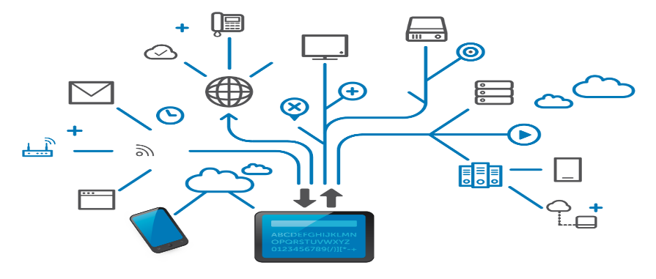

Information and Communication Technologies, commonly abbreviated as ICT or TIC (Tecnologías de la Información y Comunicación), encompass a diverse range of technologies, systems, and tools utilized to manage, transmit, and exchange information. These technologies play a fundamental role in modern society, influencing how individuals communicate, access information, conduct business, and interact with the world.

**Evolution of Information and Communication Technologies:**

The evolution of TIC spans several decades, evolving from the advent of basic communication systems to the highly sophisticated digital infrastructure we witness today. Key milestones in this evolution include:

* **Early Communication Systems:**

The inception of telegraphy and telephony laid the groundwork for long-distance communication, enabling messages to be transmitted across vast distances.

* **Computing Revolution:**

The introduction of computers and the internet revolutionized information processing and global connectivity. This period saw the emergence of email, basic websites, and early networking protocols.

* **Digital Transformation:** The proliferation of digital technologies, mobile devices, and high-speed internet connectivity accelerated the development of more advanced TIC solutions. This phase witnessed the rise of cloud computing, social media, and mobile applications, transforming how information is accessed and shared.

**Core Components of Information and Communication Technologies :**

TIC comprises various components and tools that enable communication, data management, and information exchange:

* **Communication Infrastructure:** Networks, including the internet, wireless networks, and telecommunications systems, serve as the backbone for transmitting data and facilitating global connectivity.
* **Software Applications:** An array of software applications, ranging from email clients to sophisticated collaborative tools, empowers users to communicate, collaborate, and manage information effectively.
* **Hardware Devices:** Computers, smartphones, tablets, servers, and other hardware devices form the physical infrastructure necessary to access and utilize TIC resources.
* **Data Management Systems:** Databases, storage solutions, and content management systems play a critical role in organizing and storing vast amounts of information securely.

**Importance and Impact of TIC :**

The pervasive nature of TIC has significantly impacted various aspects of society, including:

* **Business and Commerce:** TIC has revolutionized business operations, enabling global markets, streamlined workflows, and enhanced customer experiences through e-commerce and digital services.
* **Education and Learning:** TIC has transformed education by providing online learning platforms, access to vast information resources, and interactive teaching tools, fostering new avenues for learning and skill development.
* **Healthcare and Medicine:** Innovations in TIC have improved healthcare delivery through telemedicine, remote monitoring, electronic health records, and advanced diagnostic tools, enhancing patient care and accessibility.

This introduction provides a foundational understanding of TIC, setting the stage for a deeper exploration of the diverse technologies and tools that fall within this expansive domain.

1. Google Services: Enhancing Communication and Collaboration :

Google, a prominent player in the tech industry, offers a suite of services that revolutionize communication, collaboration, and productivity for both individuals and businesses. These services, collectively known as Google Workspace, encompass a range of applications designed to streamline workflows, facilitate real-time collaboration, and enhance communication efficiency.

* 1. **Google Workspace :**

Google Workspace integrates several key applications, including Gmail, Google Drive, Google Docs, Google Sheets, Google Slides, and more. These applications are hosted in the cloud, enabling seamless access to documents, emails, and collaborative tools from any internet-connected device.

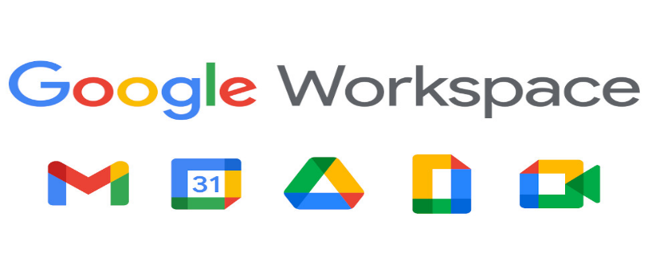

Features and Benefits:

* **Gmail:**

Gmail is a widely used email platform known for its intuitive interface, robust spam filtering, and powerful organizational tools. It serves as a central hub for communication, allowing users to manage emails efficiently.

* **Google Drive:**

Google Drive provides cloud-based storage for documents, files, and media. It allows users to store, share, and collaborate on files in real time, promoting teamwork and document version control.

* **Google Docs, Sheets, and Slides:**

These applications offer web-based document editing, spreadsheet creation, and presentation tools, allowing multiple users to work simultaneously on the same file. Real-time editing, commenting, and revision history features streamline collaboration efforts.

* 1. **Google Meet and Google Chat :**

In addition to the productivity suite, Google offers Google Meet and Google Chat as dedicated communication tools.

* **Google Meet:**

Google Meet is a video conferencing platform that enables high-quality virtual meetings, facilitating remote collaboration among teams, clients, or stakeholders. It provides features such as screen sharing, chat options, and integration with Google Calendar.

* **Google Chat:**

Google Chat is a messaging platform that allows users to communicate in real time. It supports direct messaging, group chats, file sharing, and threaded conversations, fostering quick and efficient communication among team members.

**Impact on Communication and Collaboration:**

* **Enhanced Collaboration:**

Google Services promote collaboration by allowing multiple users to work on documents simultaneously, share feedback, and track changes in real time, irrespective of geographical locations.

* **Improved Accessibility:**

The cloud-based nature of these tools ensures accessibility from various devices, enabling users to collaborate seamlessly, whether in the office, at home, or on the go.

* **Streamlined Communication:**

Google Meet and Google Chat facilitate effective communication, enabling teams to connect via video conferencing or instant messaging, thereby reducing communication barriers and enhancing teamwork.

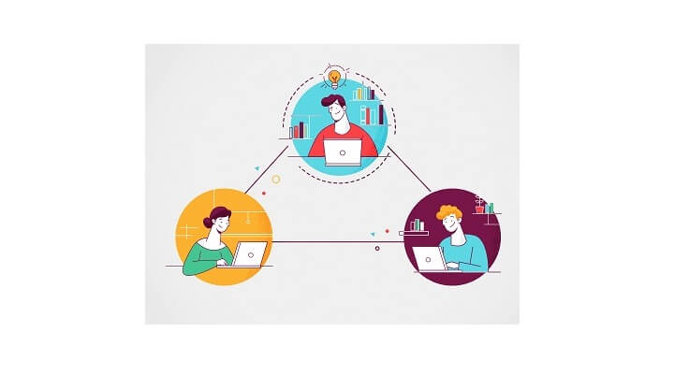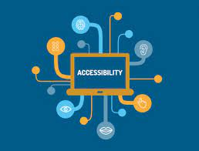

1. ***MicrosoftTools:”Empowering Productivity and Connectivity” :***

Microsoft, a global technology leader, offers a suite of tools and applications designed to boost productivity, enhance collaboration, and foster connectivity in both personal and professional settings. Microsoft's flagship suite, known as Microsoft 365, incorporates a range of applications and services tailored to meet diverse business needs.

* 1. **Microsoft 365:**

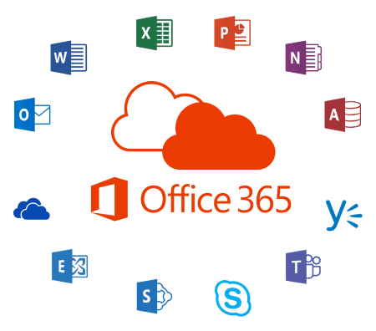

Microsoft 365 integrates a comprehensive set of applications that cater to various aspects of productivity, communication, and collaboration. Some of the core applications included are Microsoft Outlook, Word, Excel, PowerPoint, Teams, and OneDrive, among others.

**Key Components and Features:**

* **Microsoft Outlook:**

Outlook serves as a robust email client and personal information manager. It offers email organization, calendaring, task management, and contact management features.

* **Word, Excel, PowerPoint:**

These applications form the cornerstone of document creation, spreadsheet management, and presentation development, providing a familiar and powerful suite of tools for users to create and collaborate on content.

* **Microsoft Teams:**

Microsoft Teams is a collaboration platform that combines workplace chat, video meetings, file storage, and application integration, enabling teams to work and collaborate effectively in a single, integrated environment.

* **OneDrive:**

OneDrive offers cloud storage for files and documents, ensuring accessibility and seamless collaboration across devices. It facilitates secure file sharing and version control, enhancing data management and collaboration efforts.

* 1. **Microsoft Teams :**

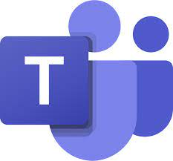

Microsoft Teams deserves particular attention for its significant role in transforming the way teams collaborate and communicate within organizations.

**Features and Impact:**

* **Unified Collaboration Platform:**

Teams provide a centralized hub where users can chat, hold video meetings, share files, and integrate third-party apps, streamlining collaboration efforts and reducing the need to switch between multiple tools.

* **Virtual Meeting Capabilities:**

With features like video conferencing, screen sharing, and meeting scheduling, Teams facilitate remote collaboration, making it an indispensable tool for organizations embracing remote or hybrid work environments.

* **Integration with Microsoft 365 Apps:**

Seamless integration with other Microsoft 365 applications allows users to edit documents, access calendars, and collaborate on files within the Teams interface, promoting productivity and efficiency.

1. ***Git: Understanding Version Control in Development :***

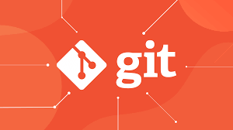

* 1. **What is Version Control?**

Version control systems like Git are fundamental tools in software development that track changes to files over time. They enable collaboration among developers, facilitate the management of different versions of a project, and provide a mechanism to revert to earlier stages if needed.

* 1. **Git: Overview and Key Concepts:**

Git is a distributed version control system designed for speed, data integrity, and support for distributed, non-linear workflows. It allows multiple developers to work on the same codebase simultaneously.

* 1. **Core Concepts:**
* **Repositories:**

Git repositories contain the entire history and content of a project. They can be local (on a developer's machine) or remote (on a server like GitHub or GitLab).

* **Commits:**

Commits are snapshots of a repository at a specific point in time. Each commit represents a set of changes made to files. These changes are tracked and can be reviewed or reverted if necessary.

* **Branches:**

Git uses branches to manage different lines of development. Developers can create, merge, or delete branches to work on features or fixes independently from the main codebase.

Absolutely, understanding Git and version control is crucial in modern development. Here's an overview:

**4.4 Workflow in Git :**

**Basic Workflow:**

* + **Initialize a Repository:**

Start tracking changes in a project by initializing a Git repository

“ git init ”

* **Stage Changes:**

Files are modified, and changes are staged for commit “git add”.

* **Commit Changes:**

Commits are created with a message describing the changes made “git commit”.

* + **Branching:**

Developers create branches to work on features or fixes separately “git branch”.

* + **Merging:**

Changes from one branch can be merged into another “git merge”.

* + **Push and Pull:**

Push commits to a remote repository “git push” or fetch and merge changes from a remote repository “git pull”.

* 1. **Benefits of Using Git:**
* **Collaboration and Safety:**

Collaboration: Git enables multiple developers to work on a project simultaneously without interfering with each other's work.

Safety Net: As every change is tracked, it provides a safety net to revert to previous versions if errors occur or to review the history of changes.

* 1. **Branching Strategies and Experimentation:**
* **Feature Branches:**

Developers can create separate branches to work on specific features or fixes without affecting the main codebase until changes are ready to be merged.

* **Experimentation:**

Git allows for experimentation and testing new ideas within isolated branches before integrating them into the main codebase.

1. ***GitHub: Leveraging Collaborative Development:***



GitHub, a web-based platform built upon Git, serves as a central hub for software development collaboration. It facilitates code hosting, version control, issue tracking, and collaboration features, empowering teams to work together efficiently on projects.

* 1. **Features and Functionality of GitHub**

**Repository Hosting:**

* **Repositories:**

GitHub hosts Git repositories, enabling users to store code, documentation, and other project files. Each repository contains the project's entire version history.

* **Collaboration Tools:**

GitHub provides features such as issues, pull requests, and project boards to facilitate communication and task management among team members.

**Pull Requests and Code Review:**

* **Pull Requests (PRs):**

PRs allow developers to propose changes, request code reviews, and discuss modifications before merging them into the main codebase.

* **Code Review:**

GitHub's review tools facilitate efficient code review processes, ensuring code quality and fostering collaboration among developers.

***Project Management:***

**Issues and Projects:**

GitHub's issue tracker enables teams to report and track bugs, feature requests, and other tasks. Project boards provide a visual overview of tasks and their statuses.

* 1. **Collaboration and Community**
  + **Forking and Contributions:**

Forking: Users can fork repositories, creating their own copy to work on changes independently. This feature encourages open-source contributions and collaborative development.

* + **Contributions:**

GitHub allows developers to contribute to open-source projects by submitting pull requests, enabling a broader community to collaborate on software development.

* 1. **Integrations and Extensibility**

***Third-Party Integrations:***

* + **Integration Ecosystem:**

GitHub integrates with various third-party tools and services, including CI/CD platforms, code analysis tools, and project management solutions, enhancing its functionality and adaptability.

1. ***Emerging Technologies in TIC:***

Advancements in technology continue to shape the landscape of Information and Communication Technologies (TIC), introducing innovative solutions that redefine how information is processed, communicated, and utilized. Several emerging technologies are poised to significantly impact various industries and transform the way we interact with data and devices.

* 1. **Artificial Intelligence (AI) and Machine Learning (ML)**

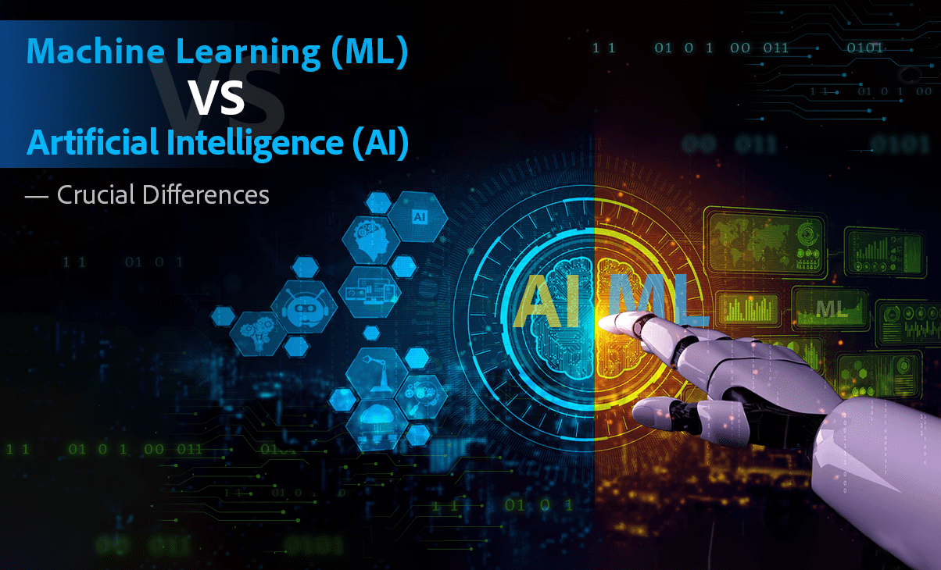

AI and ML are revolutionizing TIC by enabling machines to learn from data, make decisions, and perform tasks that traditionally required human intelligence. These technologies have widespread applications across multiple domains:

* + **Natural Language Processing (NLP):**

AI-driven NLP facilitates language understanding, enabling chatbots, virtual assistants, and language translation services.

* + **Machine Learning Algorithms:**

ML algorithms power recommendation systems, predictive analytics, and data-driven insights, optimizing processes and decision-making.

* 1. **Internet of Things (IoT)**

IoT refers to interconnected devices embedded with sensors, software, and network connectivity, enabling them to collect and exchange data. IoT is transforming various industries:

* + **Smart Cities:**

IoT enables efficient infrastructure management, traffic monitoring, waste management, and energy optimization in urban areas.

* + **Industrial LOT(LOT):**

LOT enhances manufacturing processes through remote monitoring, predictive maintenance, and real-time data analysis, improving operational efficiency.

* 1. **Blockchain Technology**

Blockchain is a decentralized and secure distributed ledger technology that offers transparency, immutability, and security in data transactions. Key applications include:

* + **Cryptocurrencies:**

Blockchain underpins cryptocurrencies like Bitcoin and Ethereum, facilitating secure peer-to-peer transactions without intermediaries.

* + **Supply Chain Management:**

Blockchain enables transparent and traceable supply chains, reducing fraud and enhancing accountability.

* 1. **Edge Computing**

Edge Computing brings computation and data storage closer to the source of data generation, reducing latency and improving real-time processing. It has implications in:

* + **IoT Networks:**

Edge computing enhances IoT by processing data closer to IoT devices, reducing latency and enabling faster responses.

* + **Enhanced Privacy and Security:**

Edge computing can enhance privacy by processing sensitive data locally, minimizing the need for data transfer over networks.

* 1. **Quantum Computing**

Quantum Computing utilizes quantum-mechanical phenomena to perform computations at an unprecedented speed, significantly impacting various fields:

* + **Complex Problem Solving:**

Quantum computing has the potential to solve complex problems in cryptography, drug discovery, optimization, and materials science that are infeasible for classical computers.

***Future Prospects and Challenges***

Emerging technologies in TIC present vast opportunities for innovation and advancement. However, challenges such as data privacy, ethical concerns, cybersecurity risks, and the need for infrastructure development must be addressed to harness their full potential.

1. ***Impact of TIC on Businesses and Society:***

Information and Communication Technologies (TIC) have had a profound impact on businesses and society, reshaping the way organizations operate, individuals communicate, and economies function. The widespread adoption and integration of TIC have led to transformative changes across various sectors and facets of daily life.

* 1. **Business Transformations**

Enhanced Connectivity and Globalization:

* + **Global Reach:**

TIC has facilitated global connectivity, enabling businesses to reach wider markets, collaborate with partners worldwide, and conduct international trade seamlessly.

* + **Remote Work Culture:**

Technologies like video conferencing, cloud computing, and collaborative tools have fueled the rise of remote work, allowing businesses to operate efficiently with geographically distributed teams.



***Increased Efficiency and Innovation:***

* + **Automation and Efficiency:**

TIC enables process automation, streamlining workflows, reducing manual labor, and enhancing operational efficiency across industries.

* + **Innovation and Agility:**

Businesses leverage TIC to innovate rapidly, adapt to changing market demands, and stay competitive by embracing emerging technologies.

* 1. **Societal Impacts**

Access to Information and Services:

* + **Information Accessibility:**

TIC has democratized access to information, enabling individuals worldwide to access knowledge, education, and services irrespective of geographical boundaries.

* + **E-Government Services:**

******Governments utilize TIC to provide citizens with online services, such as e-governance, e-health, and e-education, enhancing accessibility and convenience.

***Socio-Cultural Changes:***

* + **Changing Communication Dynamics:**

TIC has revolutionized communication, reshaping social interactions, and fostering new forms of community and connectivity through social media and online platforms.

* + **Digital Divide Concerns**:

Despite increased connectivity, disparities in access to TIC persist, leading to concerns about the digital divide between populations with and without access to technology.

* 1. **Economic Impact**

Digital Economy and Job Transformations:

* + **Digital Transformation:**

TIC fuels the digital economy, creating new industries, job roles, and economic opportunities centered around technology, data, and innovation.

* + **Job Reskilling and Displacement:**

Automation and digitalization may lead to job displacement in some sectors, emphasizing the need for continuous learning and skill upgrades.

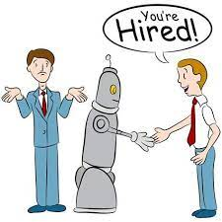

***Challenges and Considerations***

The impact of TIC on businesses and society brings forth various challenges and considerations:

* + **Cybersecurity Concerns:**

With increased connectivity, cybersecurity threats have become more prevalent, necessitating robust security measures to protect data and infrastructure.

* + **Ethical Implications:**

Issues related to data privacy, digital rights, and ethical use of technology require attention to ensure responsible and ethical use of TIC.

1. ***Future Trends in Information and Communication Technologies:***

As technology continues to advance at a rapid pace, several emerging trends in ICT are poised to revolutionize industries, transform interactions, and shape the future of technology-driven innovation.